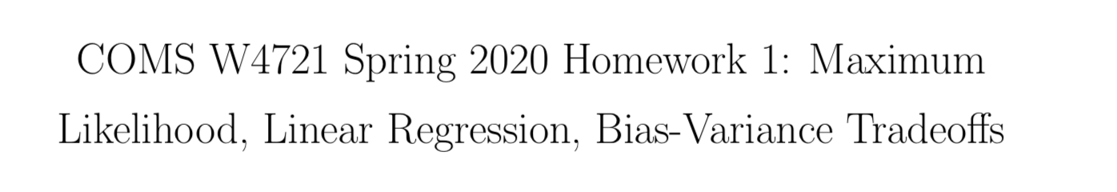

Mingrui Liu (ml4404@columbia.edu)

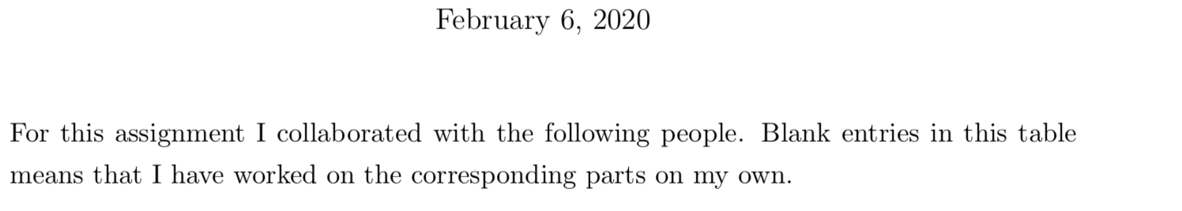

|  |  |  |
| --- | --- | --- |
| problem | Collaborators with their UNIs | part |
| Problem2 | Shuyu huang sh3967 | b |
| Problem3 | Shuyu huang sh3967 | c d |
| Problem4 | Shuyu huang sh3967 | b c d |

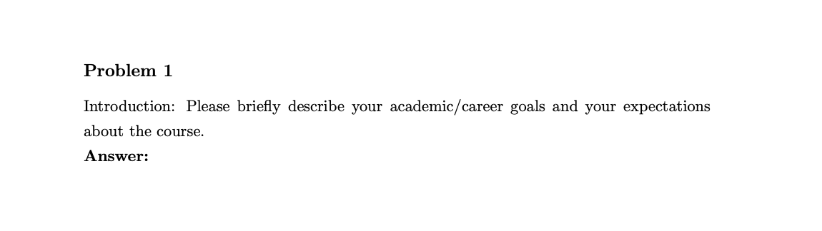

I want to become a data analyst first after graduate, to utilize the theoretical knowledge I learned and apply the data analysis ability I honed during mater school. After familiar with the industry working process and understand how the theoretical staff applied in the industry, I want to become a data science consultant, who has a technical background and can directly solve the clients' problem.

From this class, I want to learn the theory and background of machine learning models. When we need to use such a model and how we use it.

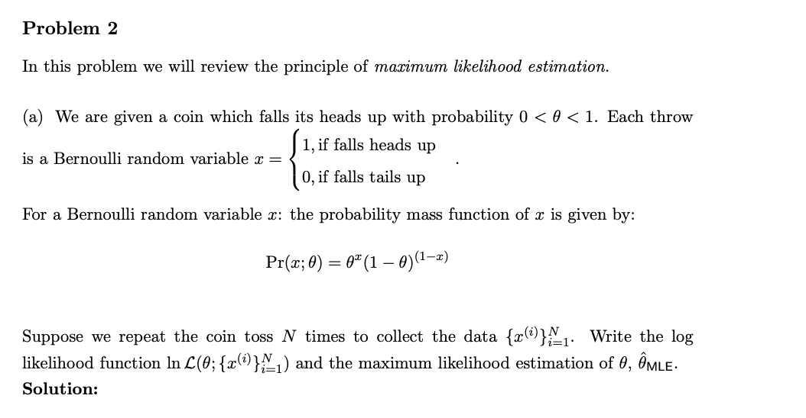

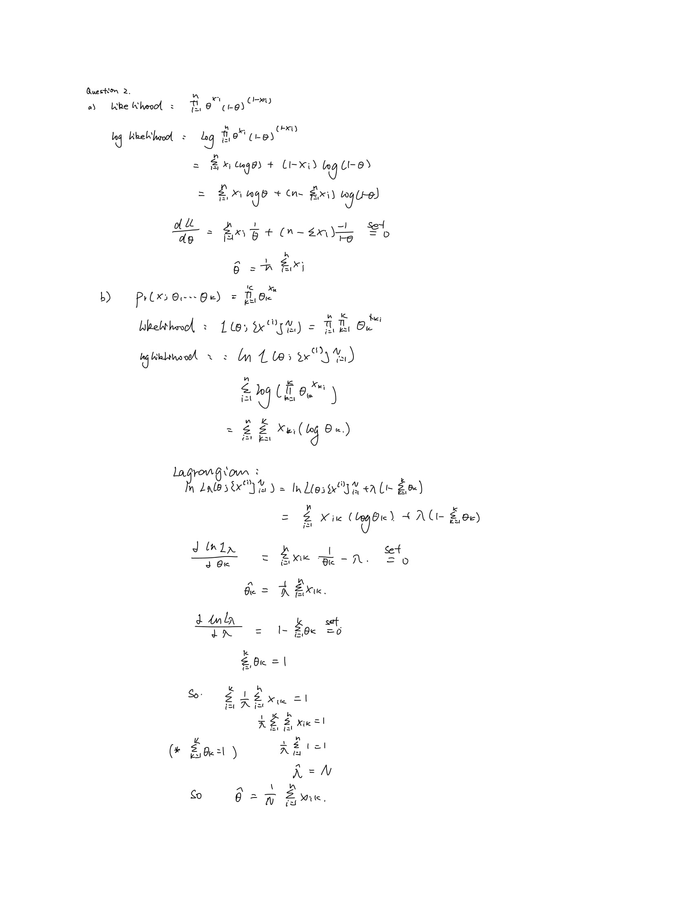

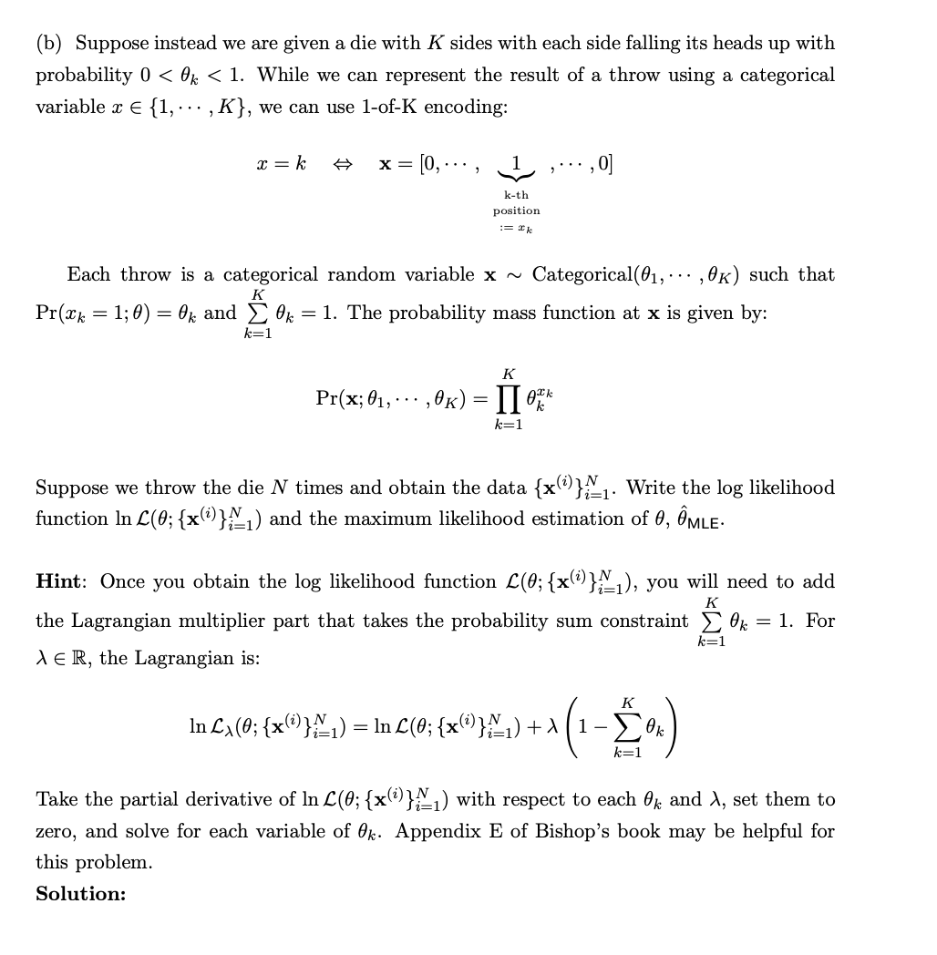



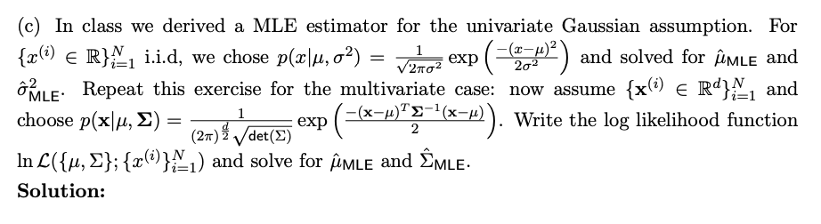

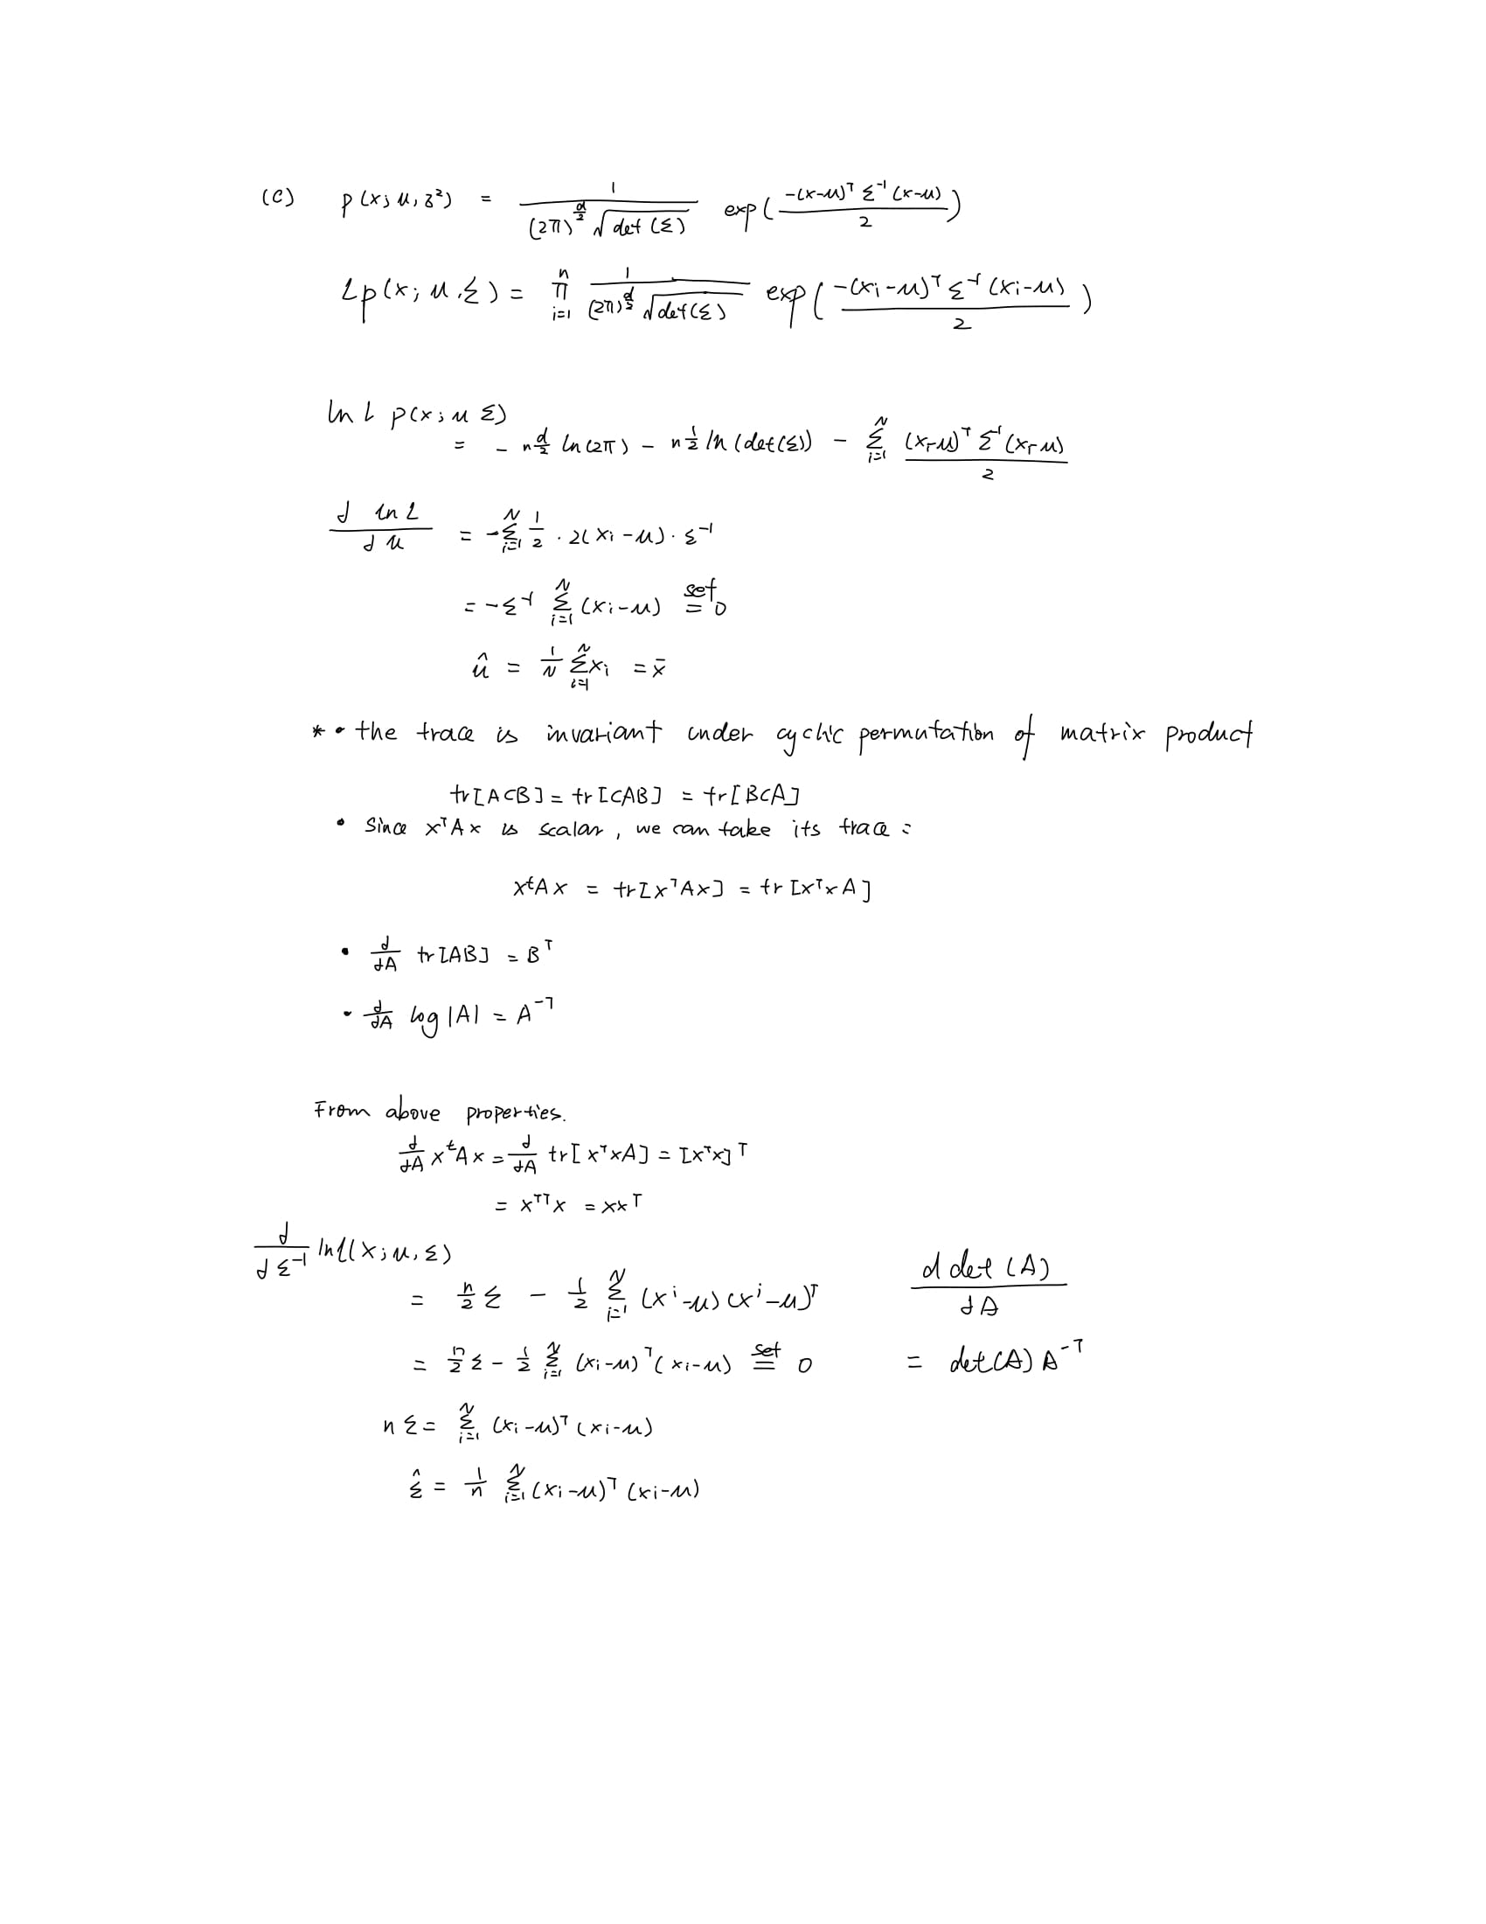

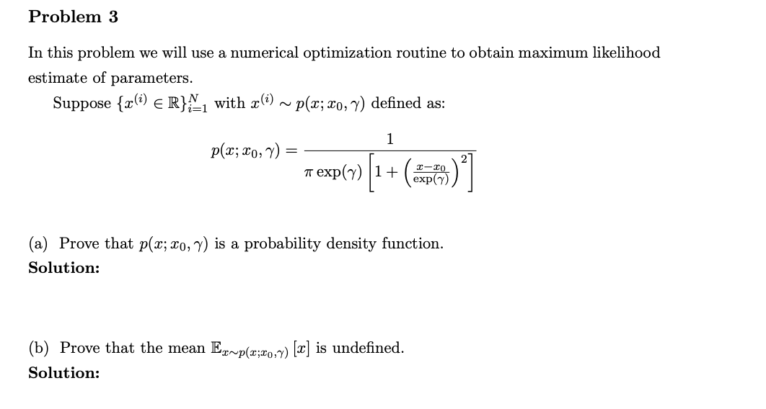

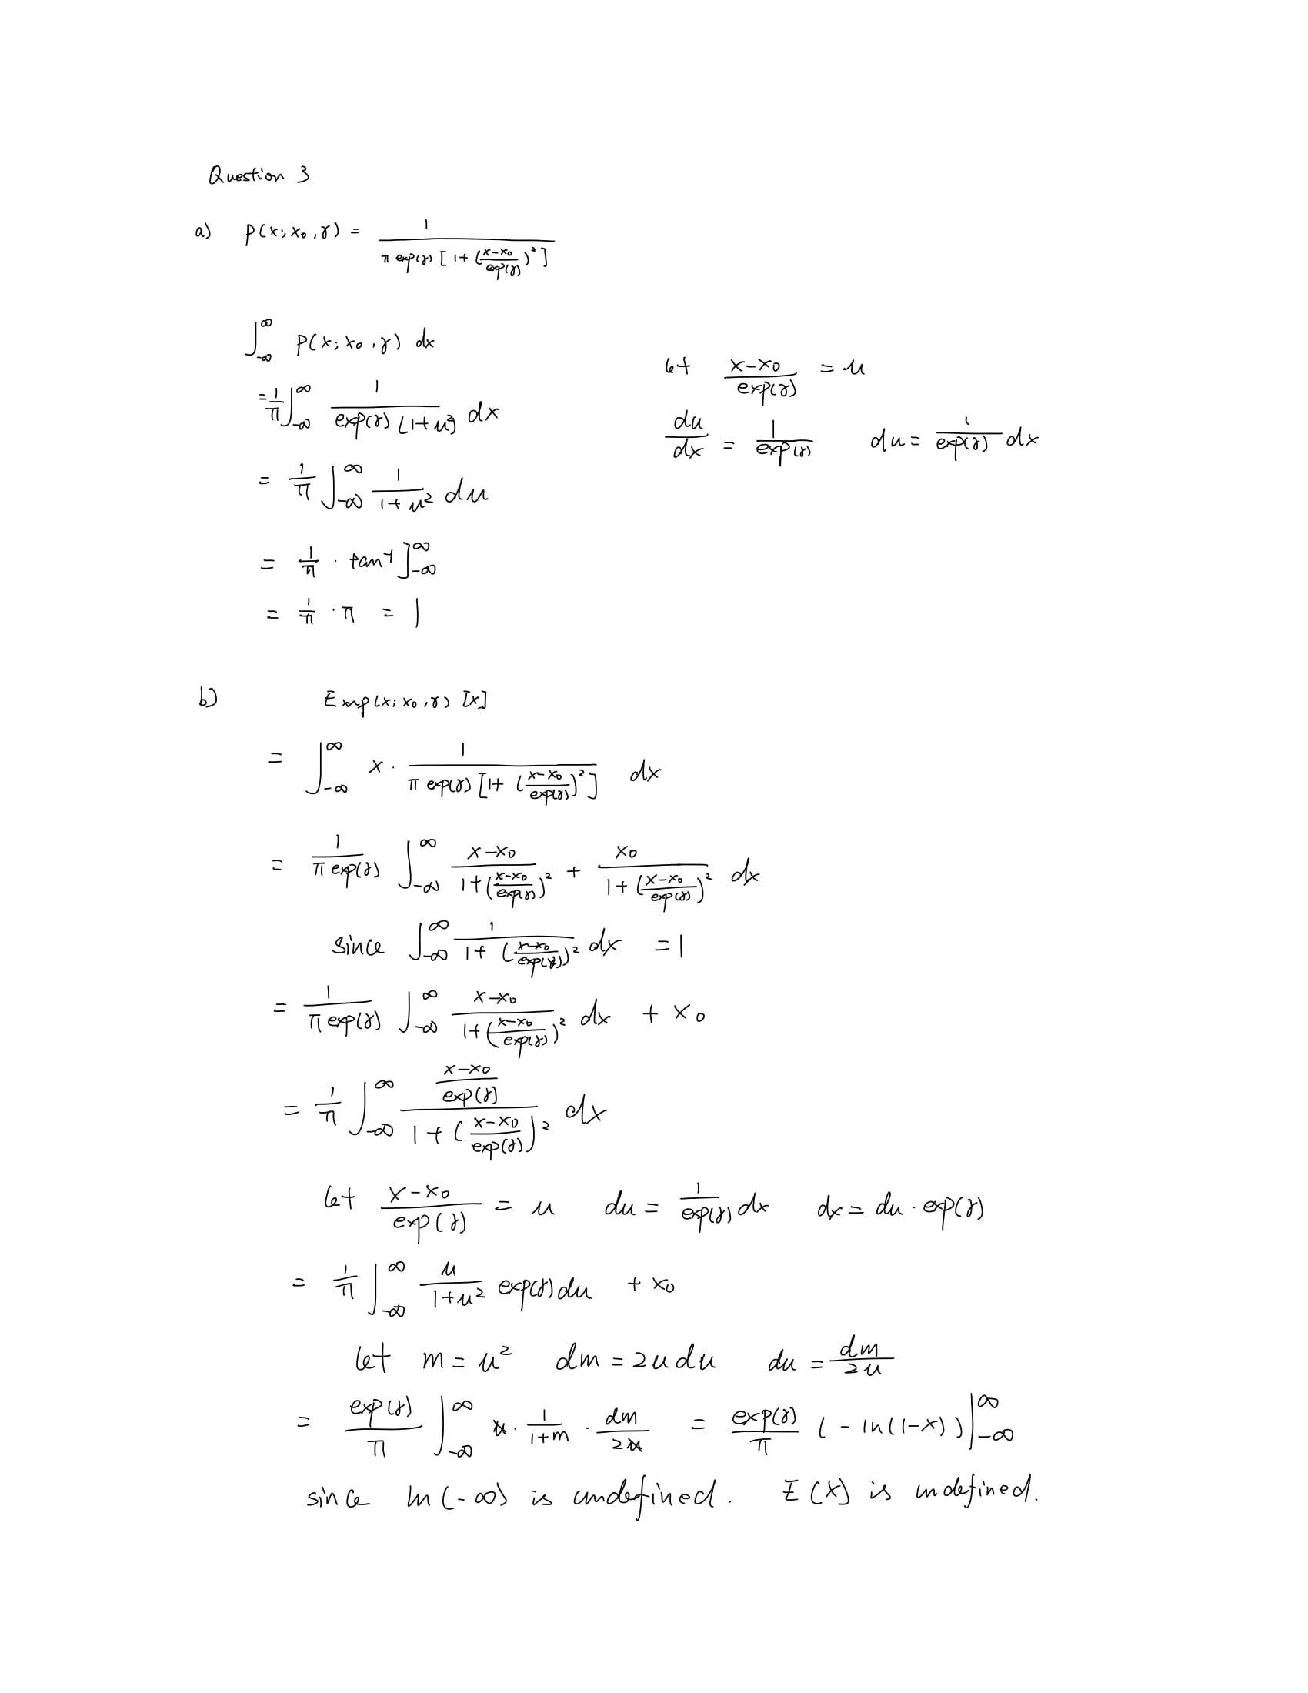

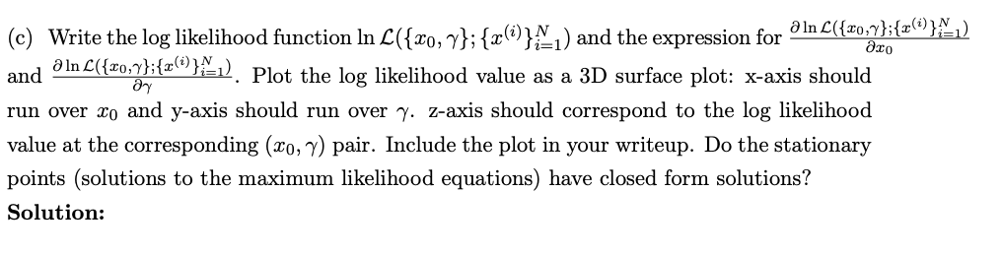

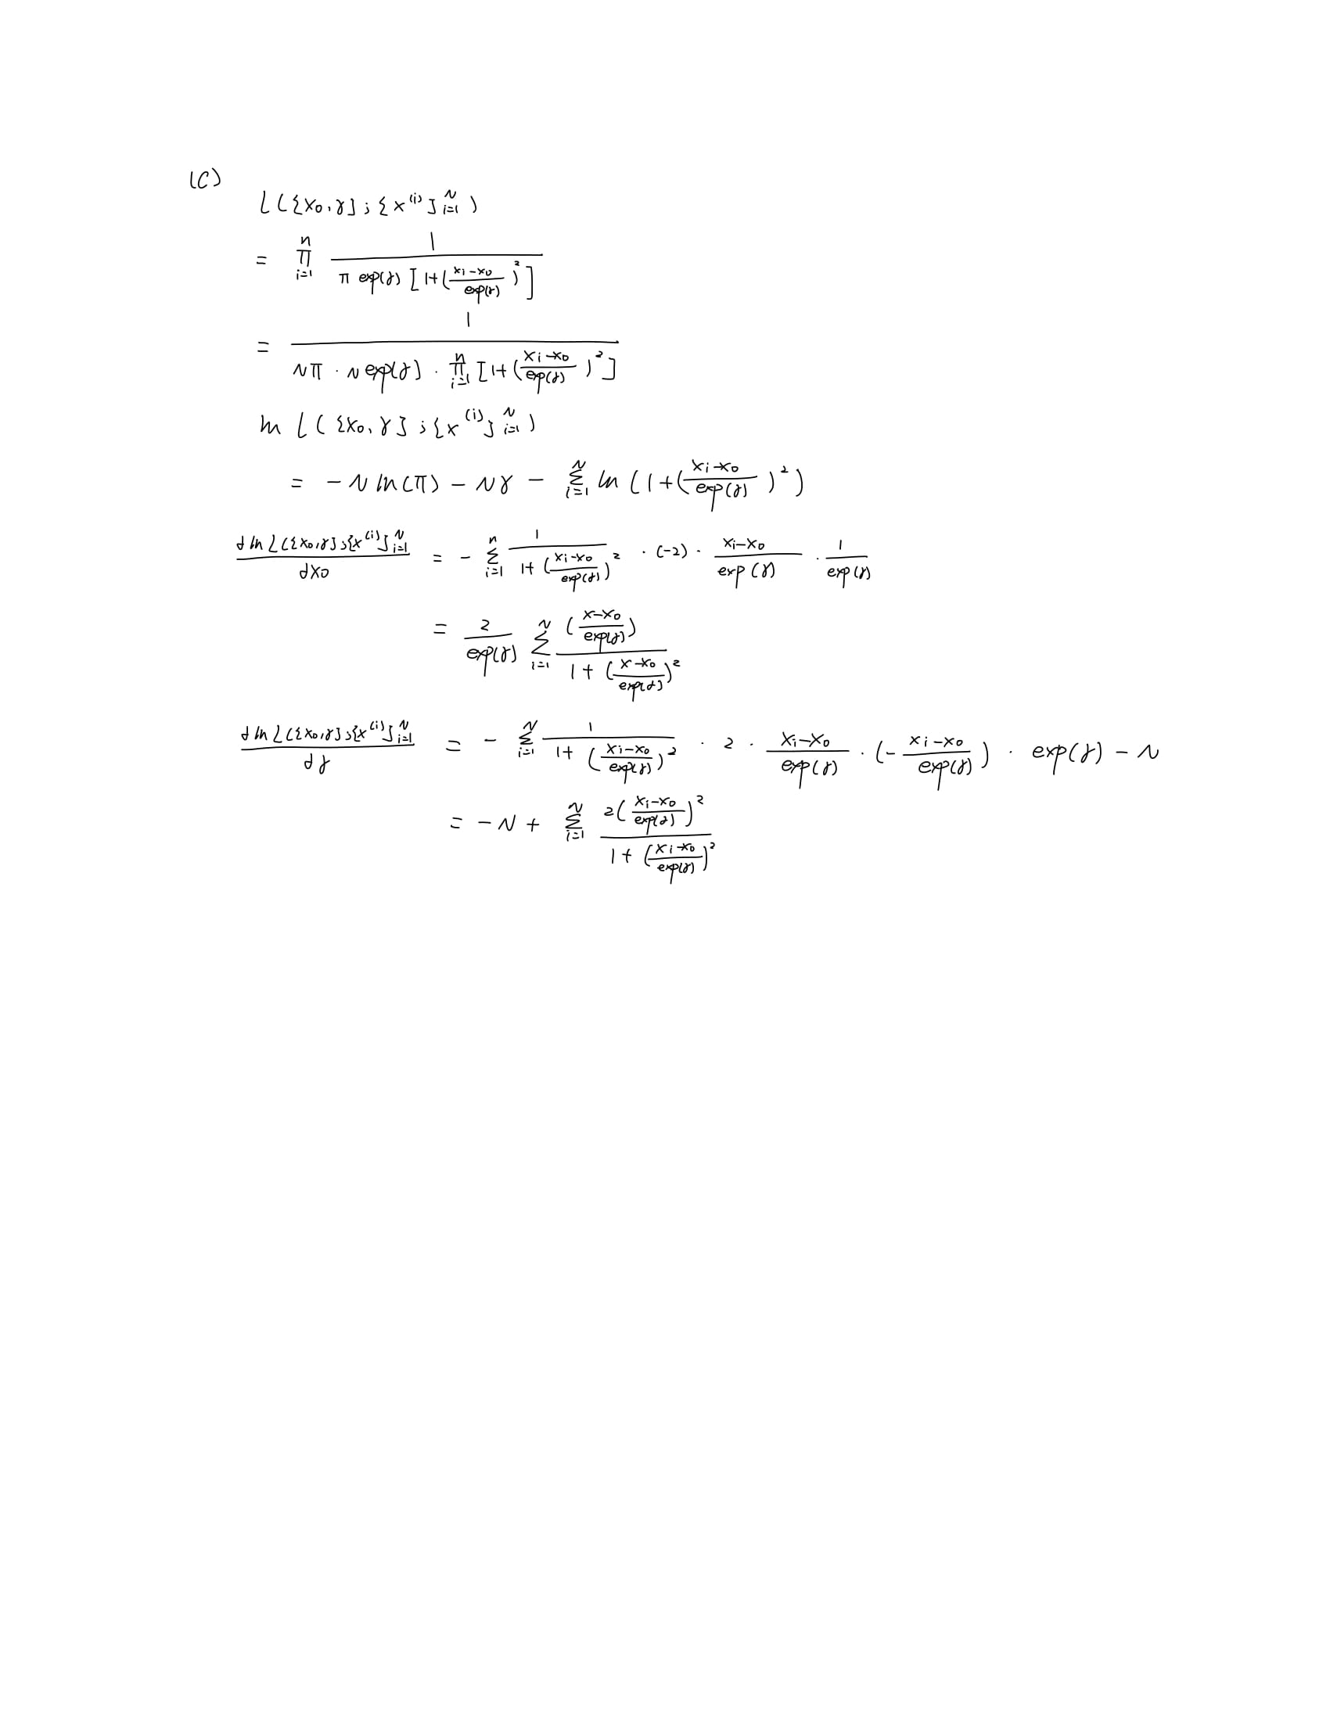

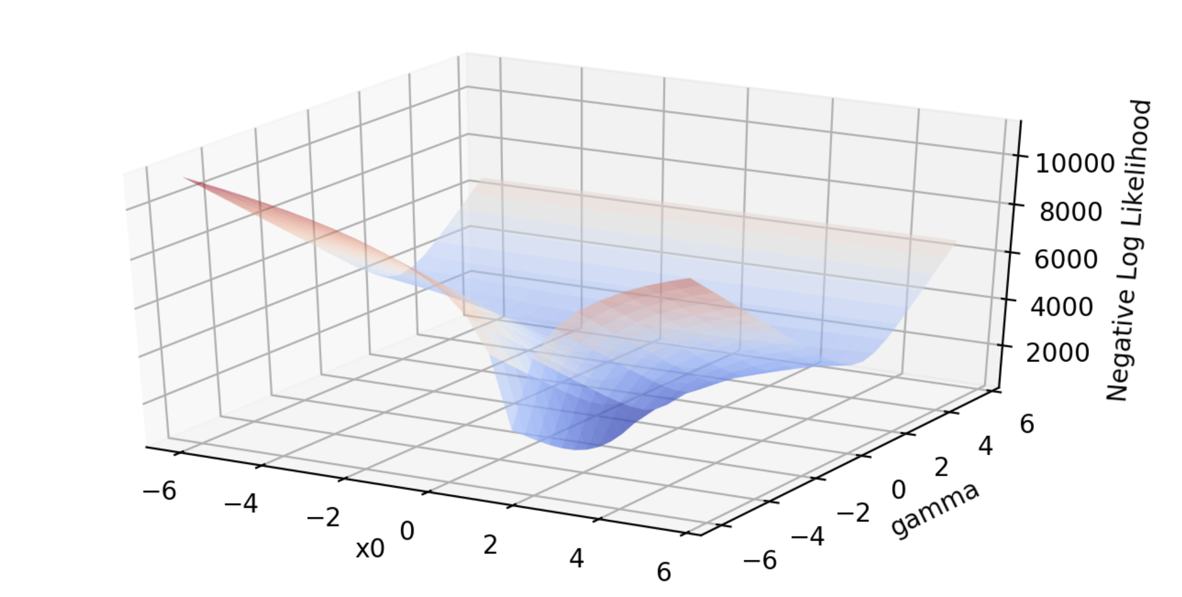

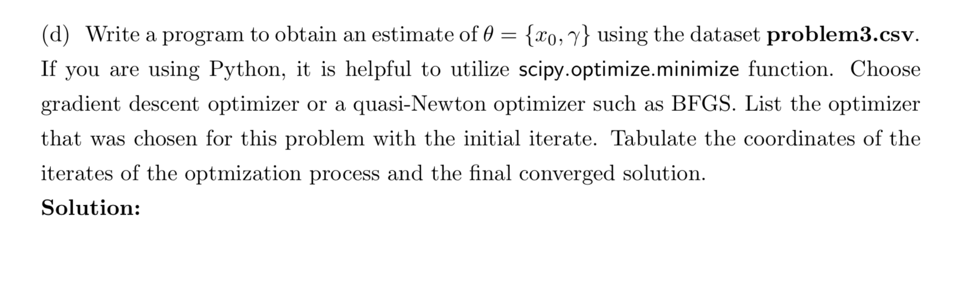

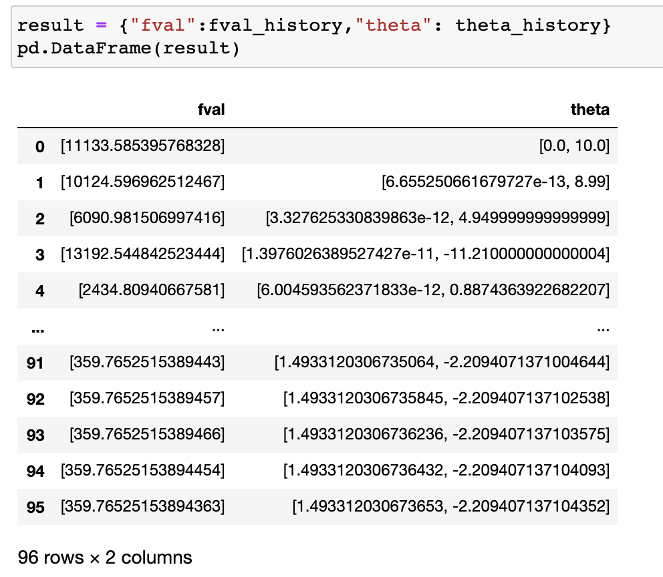

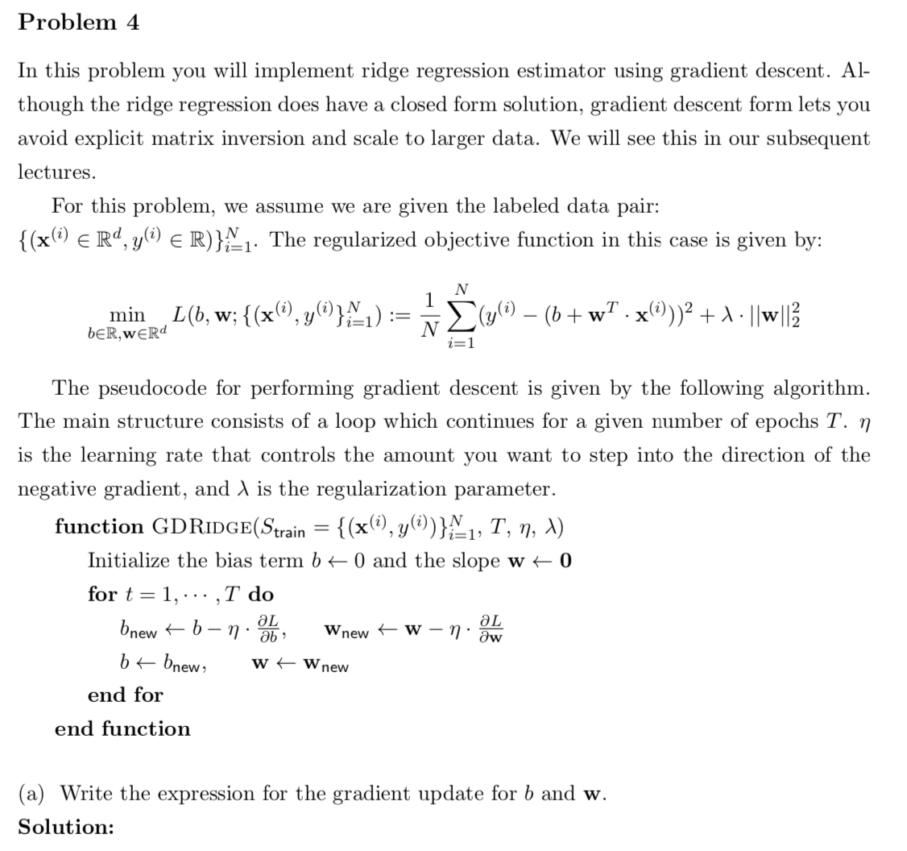

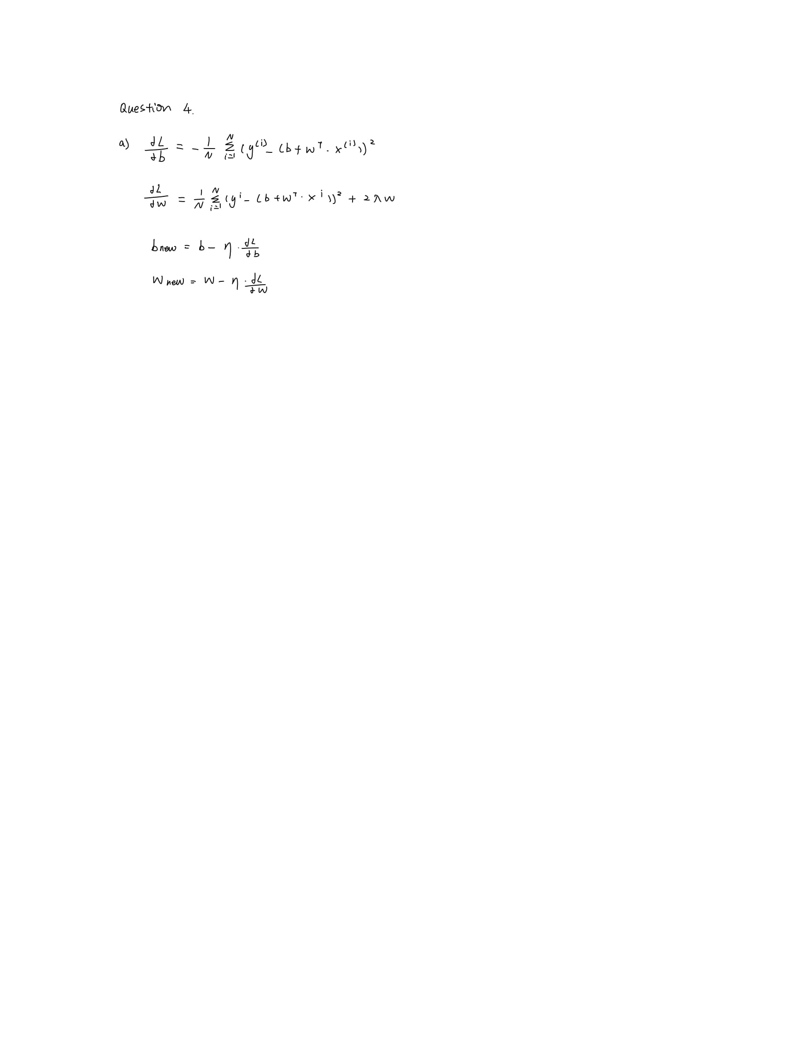

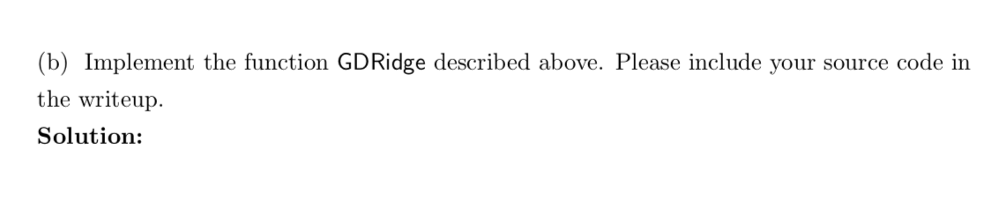

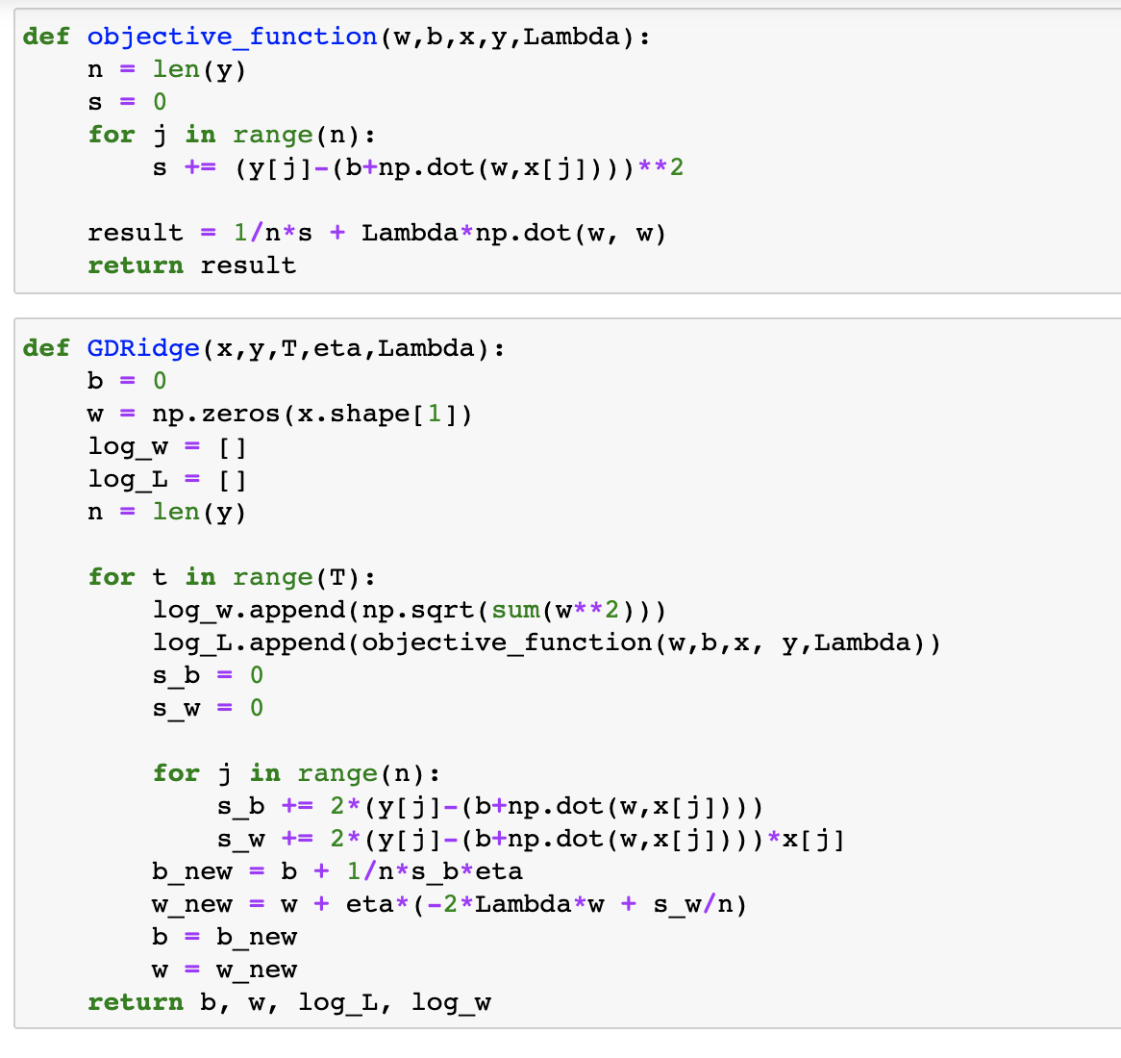

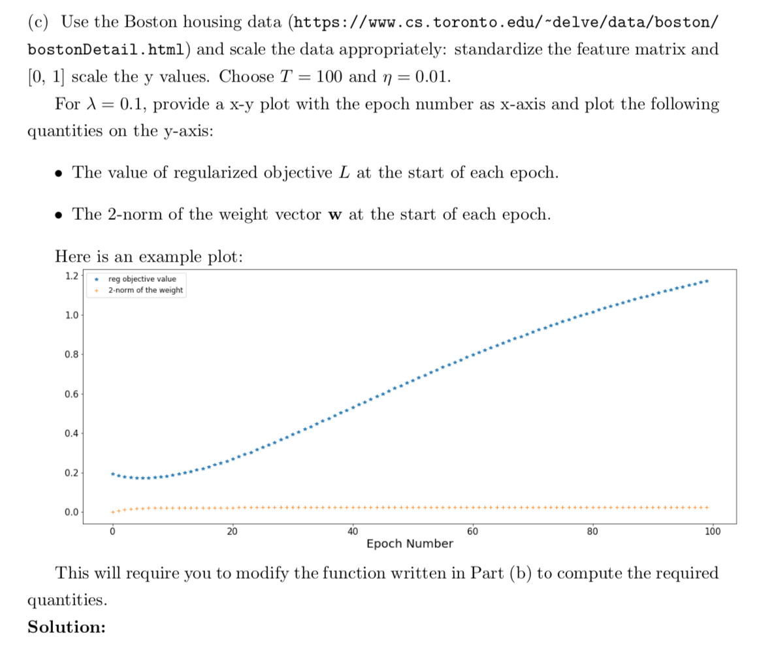

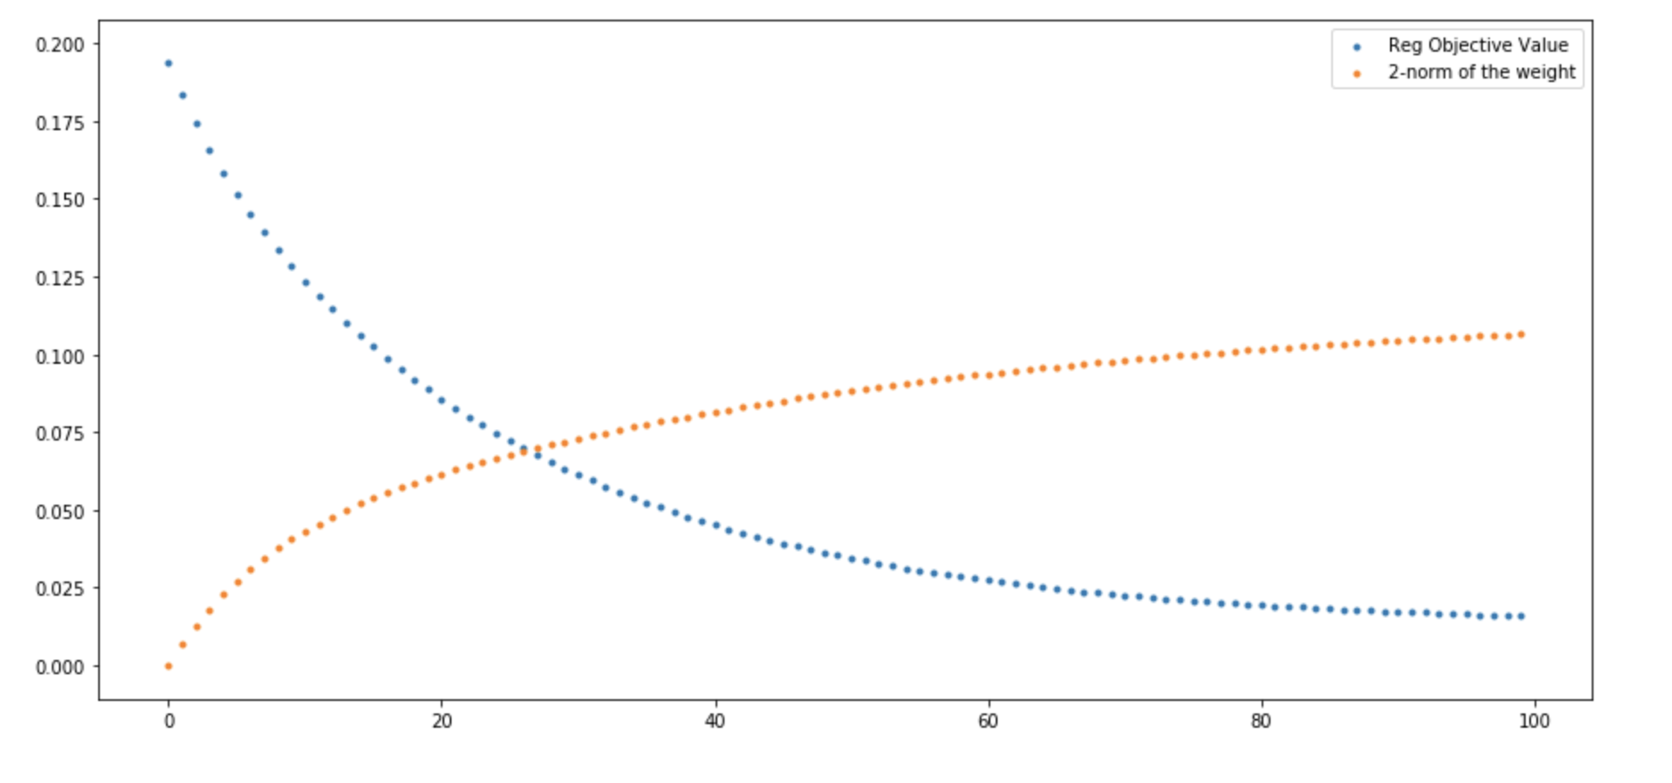

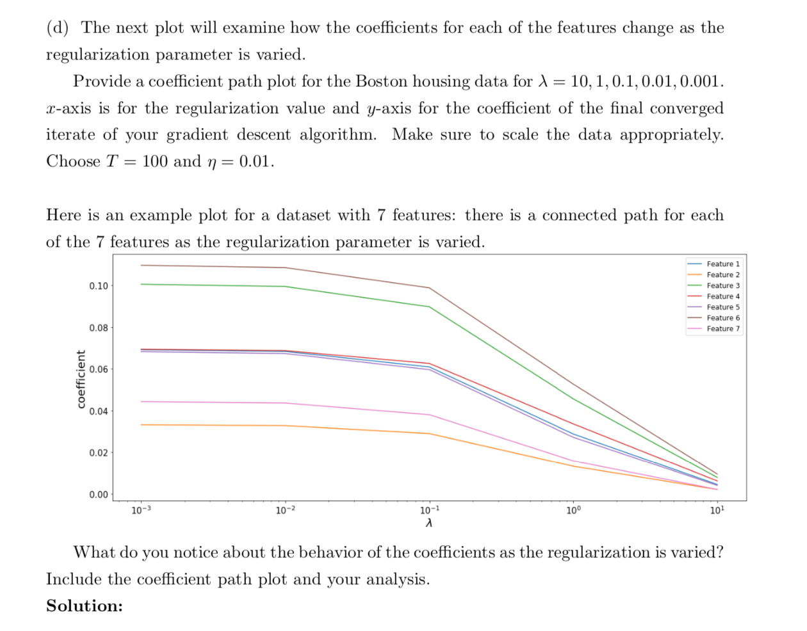

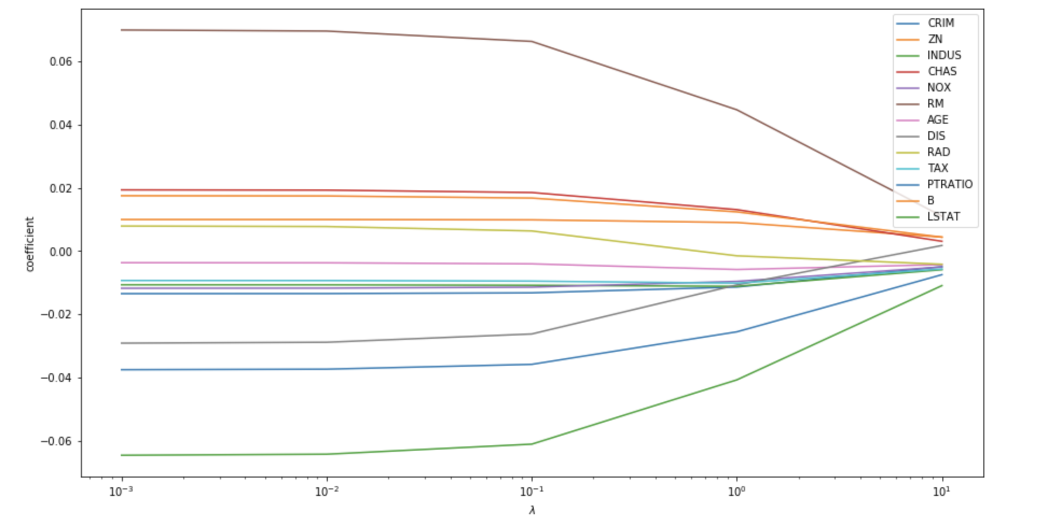

When the regularization term lambda is small, the coefficient varies a lot. Some of them have large absolute value. When the regularization term increase, to keep the cost function small, all coefficients shrink to 0 and has less impact on the final result.

In order word, the larger the regularization term, the less impact of the data itself.